**Name: KAMCHE YANN ARNAUD**

**Matricule : FE21A208**

**Department: Computer Engineering**

**Level: 300**

**Task: Implement a queue using Linked List**

1. **CODE**

/* Implementation of a Queue using Link List

Author: Kamche Yann Arnaud

Date: 12/05/2022

*/

#include<stdio.h>

#include<stdlib.h>

#include<conio.h>

struct Node{

int data;

struct Node* next;

};

struct Node* front = NULL;

struct Node* rear = NULL;

//Queue is empty

void emptyQueue(){

if (front == NULL && rear == NULL)

printf("NULL");

return;

}

//Enqueue enters an element into the queue

void Enqueue(int x){

struct Node* temp = (struct Node*)malloc(sizeof(struct Node*));

temp->data = x;

temp->next = NULL;

if(front == NULL && rear == NULL){

front = rear = temp;

return;

}

rear->next = temp;

rear = temp;

}

//Dequeue removes an element from the queue

void Dequeue(){

struct Node* temp = (struct Node*)malloc(sizeof(struct Node*));

if (front == NULL){

emptyQueue();

return;

}

if(front == rear){

front = rear = NULL;

}

else{

front = front->next;

}

free(temp);

}

//Display prints the element of the queue

void Display(){

struct Node* temp = (struct Node*)malloc(sizeof(struct Node*));

printf("front -> ");

if(front == NULL && rear == NULL){

printf("NULL");

return;

}

else{

temp = front;

while(temp != NULL){

printf("%d <-", temp->data);

temp = temp->next;

}

printf(" <-rear");

return;

}

}

//Front of the queue

int headOfQueue(){

if(front == NULL)

return -1;

else

return front->data;

}

//Rear of the queue

int endOfQueue(){

if(rear == NULL)

return -1;

else

return rear->data;

}

//size of the Queue

int sizeOfQueue(){

int count = 0;

struct Node* temp = (struct Node*)malloc(sizeof(struct Node*));

temp = front;

while(temp!= NULL){

count++;

temp = temp->next;

}

return count;

}

int main(){

system("color 2");

int choice, num;

printf("1. Enqueue\n");

printf("2. Dequeue\n ");

printf("3. Head of queue\n");

printf("4. End of queue\n");

printf("5. Display Queue\n");

printf("6. Size of queue\n");

options:

printf("\nChoose the operation to be performed on your list: ");

scanf("%d", &choice);

switch(choice){

case 1:

printf("Enter a value: ");

scanf("%d", &num);

Enqueue(num);

break;

case 2:

Dequeue();

break;

case 3:

if(headOfQueue() == -1)

printf("head: NULL");

else

printf("head: %d", headOfQueue());

break;

case 4:

if(endOfQueue() == -1)

printf("end: NULL");

else

printf("end: %d", endOfQueue());

break;

case 5:

Display();

break;

case 6:

printf("%d", sizeOfQueue());

break;

default:

break;

}

goto options;

return 0;

}

1. **COMPILATION RESULTS**
2. **ENQUEUE OPERATION**

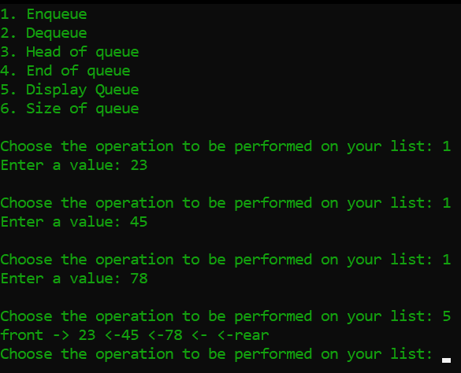

1. **DEQUEUE OPERATION**

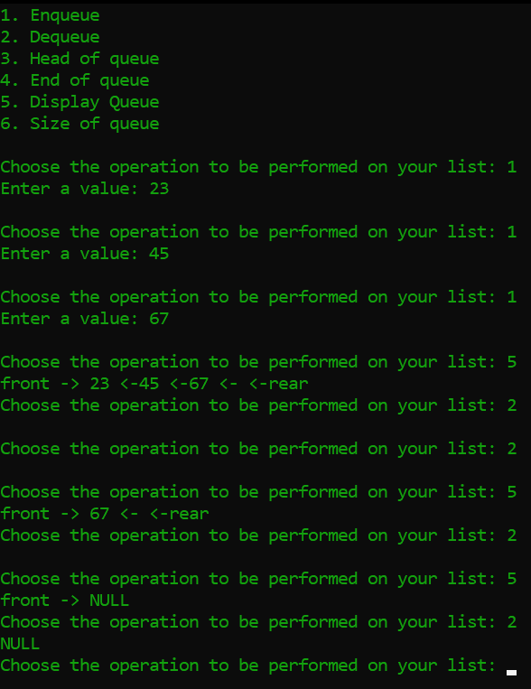

1. **DISPLAY QUEUE**

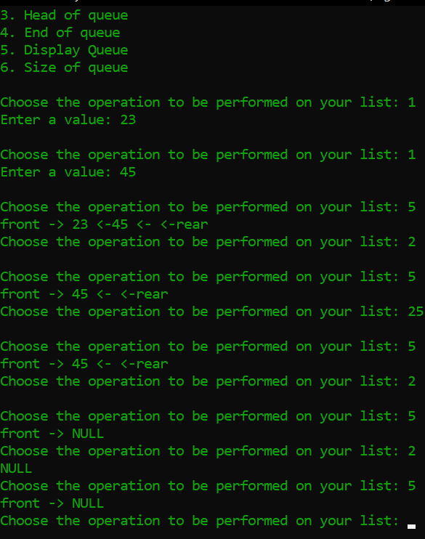

1. **HEAD OF QUEUE**

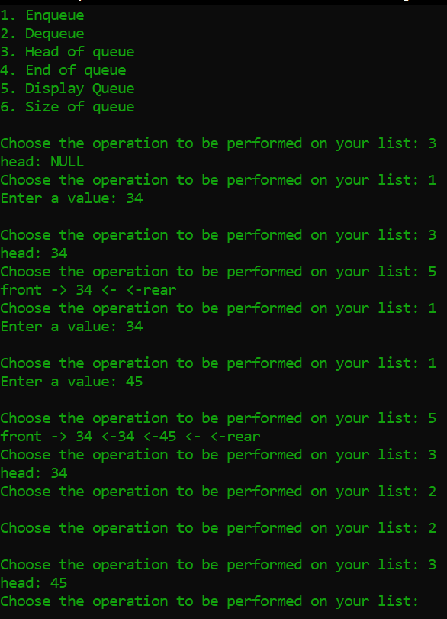

1. **END OF QUEUE**

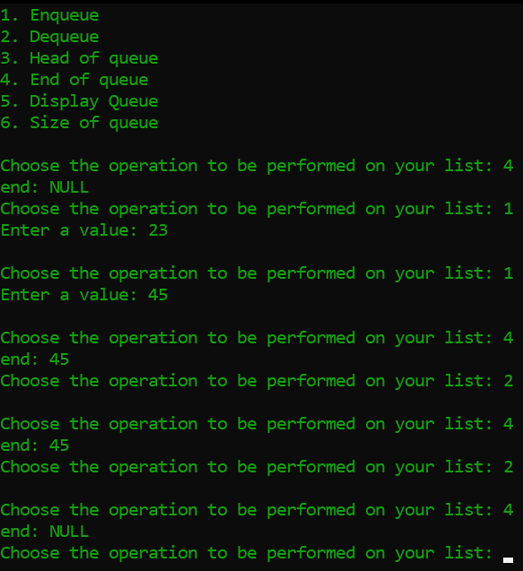

1. **SIZE OF QUEUE**

